## MINI PROJECT REPORT

**on**

**HYDXPLORE**

**Submitted in partial fulfilment for the completion of**

**B.E., IV Semester**

**INFORMATION TECHNOLOGY**

**By**

**DEVI ABHIGNA (160118737002)**

**SATHVIKA PATWARI (160118737016)**

**Under the guidance of**

**Dr.Venu Gopal Chary,**

**Professor,**

**Dept. of IT, CBIT.**



**DEPARTMENT OF INFORMATION TECHNOLOGY**

**CHAITANYA BHARATHI INSTITUTE OF TECHNOLOGY (A)**

**(Affiliated to Osmania University; Accredited by NBA(AICTE) and NAAC(UGC), ISO Certified 9001:2015)**

**GANDIPET, HYDERABAD – 500 075**

**Website:** [**www.cbit.ac.in**](http://www.cbit.ac.in)

**2019-2020**

**CHAITANYA BHARATHI INSTITUTE OF TECHNOLOGY (A)**

DEPARTMENT OF INFORMATION TECHNOLOGY

**(Affiliated to Osmania University)**

**GANDIPET, HYDERABAD – 500 075**



**CERTIFICATE**

This is to certify that the Mini Project-II entitled “**HYDXPLORE**” submitted to **CHAITANYA BHARATHI INSTITUTE OF TECHNOLOGY,** in partial fulfilment of the requirements for the completion of B.E., IV semester Information Technology, during the academic year 2019-2020, is a record of original work done by **DEVI ABHIGNA (160118737002), SATHVIKA PATWARI (160118737016)** during the period of study in the Department of IT, CBIT, HYDERABAD, under my supervision and guidance.

**Guide**  **Head of the Department**

**Dr.Venu Gopal Dr.SureshPabboju**

Professor, Dept. of IT, Professor, Dept. of IT,

CBIT, Hyderabad. CBIT, Hyderabad.

**CONTENTS**

**Page No.**

**ACKNOWLEDGEMENT** i

**DECLARATION** ii

**ABSTRACT** iii

**LIST OF FIGURES** iv

1. **INTRODUCTION** 1
   1. Objective 1
   2. Scope 1
   3. Motivation 1
   4. Problem Statement 2
   5. OverView 3
2. **EXISTING SYSTEM** 6

1. **PROPOSED SYSTEM** 73.1Methodology 8

3.2Architecture of Proposed System 8

1. **SOF****TWARE & HARDWARE REQUIREMENTS** 11
2. **IMPLEMENTATION OF PROJECT** 12
   1. Modules and description 12
   2. Results 13
3. **CONCLUSION & FUTURE SCOPE** 27

**BIBLIOGRAPHY**

**ACKNOWLEDGEMENT**

We are overwhelmed and extremely grateful to have got this wonderful opportunity to work on this phenomenal project through which we have garnered plentiful knowledge and experience.

We would like to express our deep and sincere gratitude to our project guide, **Dr.Venu Gopal**, for giving us the opportunity to do the project and providing invaluable guidance throughout this project.

We would like to thank the Head of the Department, **Dr.Suresh Pabboju**, for giving us the opportunity to improve our skills, for his constant support, and for providing us with the sources that are required for the completion of this project.

Our sincere thanks to the Principal, **Dr.P.Ravindher Reddy**, as well as the management for giving us a good opportunity to improve our skills with a good learning atmosphere.

We are extremely grateful to our parents for their love, prayers, care and sacrifices for educating and preparing us for our future and for supporting us in the completion of this project.

We would like to thank our friends for their constant help and guidance and for their support in completion of the project.

Our thanks to all the members of the staff and to the lab assistants for helping us to carry

out the groundwork of this project and for their timely support.

**DECLARATION**

This is to certify that the work reported in the present report titled “HYDXPLORE” submitted in partial fulfilment for the completion of B.E., IV Semester in the Department of Information Technology, Chaitanya Bharathi Institute of Technology, Hyderabad, is a record of original work,

No part of the report is copied from books / journals / internet and wherever the portion is taken, the same has been duly referred. The reported results are based on the project work done entirely by us and not copied from any other source.

Devi Abhigna (160118737002)

Sathvika Patwari (160118737016)

**ABSTRACT**

Tourism is a major economic activity that has developed significantly over the years. It’s an activity that can be recognized in both developed and developing nations. In general terms, tourism is the movement of a person from one place to another to visit and mesmerize the beauty of that place or to have fun. Every day a large number of people are visiting Hyderabad for seeking jobs, higher studies, business, tourism, etc.

Hydxplore is a web application, developed for an easy way to explore the city “Hyderabad”. This application provides information about businesses in the categories of dining, entertainment, retail, travel, and professional services in Hyderabad City. Here the end user can use any device which has an access to the internet, so that the user can use all the operations provide in the website on their own devices. This application can be used in place of a professional guide, get more accurate information for decision making by giving weather and social networking services.

Hydxplore provides an easier way for the users for searching a location, calculating distance between two locations, getting textual and pictorial information of the place you search in a single application. This application uses Google Maps, Internet and cellular data to provide its services, can be used from anywhere using internet service to get details of the city. One can see all the necessary information about the city through this application once they register. The built in GPS (Global Positioning System) provides latitude and longitude coordinates of the locations.

This application is developed using HTML, JavaScript, CSS, PHP (for the front End) and DataBase (for the bank end).

**LIST OF FIGURES**

|  |  |  |
| --- | --- | --- |
| **Figure** | **Description** | **Page No.** |
| Fig. 5.1 | Main page |  |
| Fig. 5.2 | Main page before logging in |  |
| Fig. 5.3 | Signup form |  |
| Fig. 5.4 | Login form |  |
| Fig. 5.5 | Login form when you enter wrong details |  |
| Fig. 5.6 | Weather forecast |  |
| Fig. 5.7 | Shopping |  |
| Fig. 5.8 | Shopping |  |
| Fig. 5.9 | Directions page |  |
| Fig. 5.10 | Hotels page |  |
| Fig. 5.11 | Hotels page |  |
| Fig. 5.12 | Hotels page |  |
| Fig. 5.13 | Hotels page |  |
| Fig. 5.14 | Hotels page |  |
| Fig. 5.15 | Book a hotel |  |
| Fig. 5.16 | Tourist spots |  |
| Fig. 5.17 | Historic places |  |
| Fig. 5.18 | Historic places |  |
| Fig. 5.19 | Historic places |  |
| Fig. 5.20 | Directions page |  |
| Fig. 5.21 | Museums |  |
| Fig. 5.22 | Museums |  |
| Fig. 5.23 | Amusement parks |  |
| Fig. 5.24 | Amusement parks |  |
| Fig. 5.25 | Contact us page |  |
| Fig. 5.26 | Main page |  |
| Fig. 5.27 | Logout page |  |

1. **INTRODUCTION**

**1.1 Objective**

The Hydxplore is a web application, developed for an easy way to explore the city “Hyderabad”. This application provides information about businesses in the categories of dining, entertainment, retail, travel, and professional services in Hyderabad City. Mainly aimed to produce a tourist guide for Hyderabad City, which can efficiently guide the tourists who visits Hyderabad.

**1.2 Scope**

The scope of this project is to provide an easy way to explore the city “Hyderabad”. The application must be user-friendly. The User should be able to search appropriate location. The User should be able to retrievefull information (address, contact number, directions and other information) for the any selected location. The User should feel free to suggest ideas and give a feedback.

**1.3 Motivation**

Tourism is a major economic activity that has developed significantly over the years. It’s an activity that can be recognized in both developed and developing nations. In general terms, tourism is travelling from one place to another to visit and mesmerize the beauty of that place or to have fun. **Travelling is the kind of activity**, which almost all the people love. For someone it is an opportunity to relax and abstract from everyday busy life. For others it is interesting to **observe the way people of other cultures** and mentality live. Some people consider it to be the **best way to have fun** and always try to visit as many clubs, pubs, restaurants and cafes as possible for their wallets and time limits. During their travel tourists find many problems for booking hotels, searching for places etc.

The idea of this project was obtained after going through all the tourism websites, where we got to know the problems facing by the users. Keeping this in mind we came with the solution and developed this project. The web application Hydxplore is mainly aimed to produce a tourist guide for Hyderabad City, which can efficiently guide the tourist who visits Hyderabad. It gives a clear information about the historic places, museums, amusement parks, shopping malls etc., and also provides the directions for your selected destination.

**1.4 Problem Statement**

**Travelling is the kind of activity**, which almost all the people love. For someone it is an opportunity to relax and abstract from everyday busy life. For others it is interesting to **observe the way people of other cultures** and mentality live. Some people consider it to be the **best way to have fun** and always try to visit as many clubs, pubs, restaurants and cafes as possible for their wallets and time limits.

During their travel tourists find many problems for booking hotels, searching for places etc. Tourists contact travel agencies or they use many third-party apps to explore and know about a place. Travel agencies charge a large amount from tourists and on the other hand third party apps make profits by collaborating with some hotels and showing information which is manipulated rather than the actual information.

Third party apps also ask the users to pay to access the premium content in their apps. These sources trouble the tourists and leads to a negative impact on tourism.

To resolve these problems, we came up with Hydxplore ‘a tourist guide for Hyderabad City’, which can efficiently guide the tourists who visits Hyderabad. This application provides information about businesses in the categories of dining, entertainment, retail, travel, and professional services in Hyderabad City. In this application one can know the textual and pictorial information of the place you search, its location and its directions. Booking of hotels can also be done without any trouble through the official websites of the hotel you want to stay in. The prices of the hotel rooms will be the actual prices because in this application as soon as you select the book-now it is directed to the official page of the hotel where the price is given by the hotel itself. This application gives more accurate information for decision making by giving weather and social networking services. It saves their time and also gives clear information. One need not go around the agencies or guides. All the details can be known just in a single click.

**1.5 Overview**

The Hydxplore is a web application, developed using HTML, CSS, JavaScript, PHP and MySql. This application is designed for an easy way to explore the city “Hyderabad”. This application provides information about businesses in the categories of dining, entertainment, retail, travel, and professional services in Hyderabad City.

This application consists of a homepage, login page, register page, hotels page, shopping malls page, tourists-spots, contact page. If the user is new to this application, he/she should first register and then login into the application and search for the places. In this application one can know the textual and pictorial information of the place you search, its location and its directions. Booking of hotels can also be done without any trouble through the official websites of the hotel you want to stay in. The prices of the hotel rooms will be the actual prices because in this application as soon as you select the book-now it is directed to the official page of the hotel where the price is given by the hotel itself. This application gives more accurate information for decision making by giving weather and social networking services. It saves their time and also gives clear information. One need not go around the agencies or guides. All the details can be known just in a single click.

**HTML**

**HTML** (HyperText Markup Language) is the most basic building block of the Web. It defines the meaning and structure of web content. Other technologies besides HTML are generally used to describe a web page's appearance/presentation.

"Hypertext" refers to links that connect web pages to one another, either within a single website or between websites. Links are a fundamental aspect of the Web. By uploading content to the Internet and linking it to pages created by other people, you become an active participant in the World Wide Web. HTML markup includes special “elements” such as  [<head>](https://developer.mozilla.org/en-US/docs/Web/HTML/Element/head), [<title>](https://developer.mozilla.org/en-US/docs/Web/HTML/Element/title), [<body>](https://developer.mozilla.org/en-US/docs/Web/HTML/Element/body), [<header>](https://developer.mozilla.org/en-US/docs/Web/HTML/Element/header), [<footer>](https://developer.mozilla.org/en-US/docs/Web/HTML/Element/footer), [<article>](https://developer.mozilla.org/en-US/docs/Web/HTML/Element/article), [<section>](https://developer.mozilla.org/en-US/docs/Web/HTML/Element/section), [<p>](https://developer.mozilla.org/en-US/docs/Web/HTML/Element/p), [<div>](https://developer.mozilla.org/en-US/docs/Web/HTML/Element/div), [<span>](https://developer.mozilla.org/en-US/docs/Web/HTML/Element/span), [<img>](https://developer.mozilla.org/en-US/docs/Web/HTML/Element/img), [<nav>](https://developer.mozilla.org/en-US/docs/Web/HTML/Element/nav), [<output>](https://developer.mozilla.org/en-US/docs/Web/HTML/Element/output), [<progress>](https://developer.mozilla.org/en-US/docs/Web/HTML/Element/progress), [<video>](https://developer.mozilla.org/en-US/docs/Web/HTML/Element/video), [<ul>](https://developer.mozilla.org/en-US/docs/Web/HTML/Element/ul), [<ol>](https://developer.mozilla.org/en-US/docs/Web/HTML/Element/ol), [<li>](https://developer.mozilla.org/en-US/docs/Web/HTML/Element/li) and many others.

An HTML element is set off from other text in a document by "tags", which consist of the element name surrounded by "<" and ">".  The name of an element inside a tag is case insensitive. That is, it can be written in uppercase, lowercase, or a mixture. For example, the <title> tag can be written as <Title>, <TITLE>, or in any other way.

**CSS**

**CSS** (**C**ascading **S**tyle **S**heets) is a simply designed language intended to simplify the process of making web pages presentable. CSS allows you to apply styles to web pages. More importantly, CSS enables you to do this independent of the HTML that makes up each web page.  
CSS is easy to learn and understood but it provides powerful control over the presentation of an HTML document. A CSS comprises of style rules that are interpreted by the browser and then applied to the corresponding elements in your document.  
A style rule set consists of a selector and declaration block.

**JavaScript**

**JavaScript** (**JS**) is a lightweight, interpreted, or [just-in-time](https://en.wikipedia.org/wiki/Just-in-time_compilation) compiled programming language with [first-class functions](https://developer.mozilla.org/en-US/docs/Glossary/First-class_Function). While it is most well-known as the scripting language for Web pages, [many non-browser environments](https://en.wikipedia.org/wiki/JavaScript#Uses_outside_Web_pages) also use it, such as [Node.js](https://developer.mozilla.org/en-US/docs/Glossary/Node.js) and many more. JavaScript is a [prototype-based](https://developer.mozilla.org/en-US/docs/Glossary/Prototype-based_programming), multi-paradigm, single-threaded, dynamic language, supporting object-oriented, imperative, and declarative (e.g. functional programming) styles. JavaScript was initially created to “make web pages alive”.

The programs in this language are called scripts. They can be written right in a web page’s HTML and run automatically as the page loads. Scripts are provided and executed as plain text. They don’t need special preparation or compilation to run.

**PHP**

**PHP** (Hypertext Preprocessor) started out as a small open source project that evolved as more and more people found out how useful it was. Rasmus Lerdorf unleashed the first version of PHP way back in 1994.

* PHP is a server-side scripting language that is embedded in HTML. It is used to manage dynamic content, databases, session tracking, even build entire e-commerce sites.
* It is integrated with a number of popular databases, including MySQL, PostgreSQL, Oracle, Sybase, Informix, and Microsoft SQL Server.
* PHP is pleasingly zippy in its execution, especially when compiled as an Apache module on the Unix side. The MySQL server, once started, executes even very complex queries with huge result sets in record-setting time.
* PHP Syntax is C-Like.

## Common uses of PHP

* PHP performs system functions, i.e. from files on a system it can create, open, read, write, and close them.
* PHP can handle forms, i.e. gather data from files, save data to a file, through email you can send data, return data to the user.
* You add, delete, modify elements within your database through PHP.
* Using PHP, you can restrict users to access some pages of your website.
* It can encrypt data.

MySQL

MySQL is a fast, easy-to-use RDBMS (Relational DataBase Management System) being used for many small and big businesses. MySQL is developed, marketed and supported by MySQL AB, which is a Swedish company. MySQL is becoming so popular because of many good reasons −

* MySQL is released under an open-source license. So you have nothing to pay to use it.
* MySQL is a very powerful program in its own right. It handles a large subset of the functionality of the most expensive and powerful database packages.
* MySQL uses a standard form of the well-known SQL data language.
* MySQL works on many operating systems and with many languages including PHP, PERL, C, C++, JAVA, etc.
* MySQL works very quickly and works well even with large data sets.
* MySQL is very friendly to PHP, the most appreciated language for web development.
* MySQL supports large databases, up to 50 million rows or more in a table
* MySQL is customizable. The open-source GPL license allows programmers to modify the MySQL software to fit their own specific environments.

**2. EXISTING SYSTEM**

In the existing system, tourists find many problems for booking hotels, searching for places etc. Tourists contact travel agencies or they use many third-party apps to explore and know about a place. Travel agencies charge a large amount from tourists and on the other hand third party apps make profits by collaborating with some hotels and showing information which is manipulated rather than the actual information.

Third party apps also ask the users to pay to access the premium content in their apps. These sources trouble the tourists and leads to a negative impact on tourism.

To resolve these problems, we came up with Hydxplore ‘a tourist guide for Hyderabad City’, which can efficiently guide the tourists who visits Hyderabad. This application provides information about businesses in the categories of dining, entertainment, retail, travel, and professional services in Hyderabad City. In this application one can know the textual and pictorial information of the place you search, its location and its directions. Booking of hotels can also be done without any trouble through the official websites of the hotel, you want to stay in. The prices of the hotel rooms will be the actual prices because in this application as soon as you select the book-now it is directed to the official page of the hotel where the price is given by the hotel itself. This application gives more accurate information for decision making by giving weather and social networking services.

This application uses Google Maps, Internet and cellular data to provide its services. This application can be used from anywhere using internet service and all the details of the city can be accessed. One can see all the necessary information about the city through this application once they register. The built in GPS (Global Positioning System) provides latitude and longitude coordinates of the locations.

**3. PROPOSED SYSTEM**

In the proposed system, to resolve the above problems, we came up with Hydxplore ‘a tourist guide for Hyderabad City’, which can efficiently guide the tourists who visits Hyderabad. This application provides information about businesses in the categories of dining, entertainment, retail, travel, and professional services in Hyderabad City. In this application one can know the textual and pictorial information of the place you search, its location and its directions. Booking of hotels can also be done without any trouble through the official websites of the hotel, you want to stay in. The prices of the hotel rooms will be the actual prices because in this application as soon as you select the book-now it is directed to the official page of the hotel where the price is given by the hotel itself. This application gives more accurate information for decision making by giving weather and social networking services.

           This application uses Google Maps, Internet and cellular data to provide its services. This application can be used from anywhere using internet service and all the details of the city can be accessed. One can see all the necessary information about the city through this application once they register. The built in GPS (Global Positioning System) provides latitude and longitude coordinates of the locations.

**3.1 Methodology**

This project consists of the following modules:

Admin: The admin has full access to the application. The admin can view all the details, manage the application such as add, edit and delete.

User: The user is the one who uses the application. The user should enter the details to login the application. Then can know the information regarding all the places located in Hyderabad.

Data Base: The database module stores the details of the user who registers the application.

**3.2 Architecture Of Proposed System**

The user needs to follow the following steps:

* In the Main page, Click on login box.
* As soon as you click on the login button, a login form appears in which you need to fill your details and click on submit.
* If you are a new user, you need to register and then login.
* As you are logged in, you can search for the required places.
* After finding the required information, you need to logout.

LOGIN

NOT REGISTERED

ENTER YOUR DETAILS

ENTER USERNAME AND PASSWORD

CONTACT US

HOME

HOTELS

ABOUT US

TOURIST SPOTS

SHOPPING

HISTORIC PLACES

MUSEUMS

AMUSEMENT PARKS

**`**

LOGOUT

**Fig.3.1 Architecture Of Proposed System**

The website can be followed in the following steps shown in the above Fig.3.1. by the user.

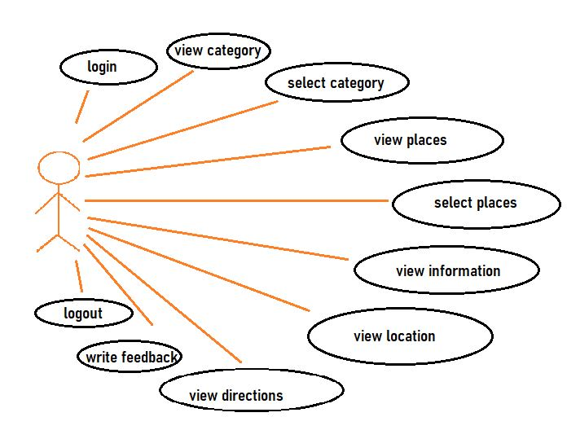

**Fig.3.2 Use Case Diagram**

**4. SOFTWARE AND HARDWARE REQUIREMENTS**

**Software Requirements:**

|  |  |
| --- | --- |
| Operating System | Windows 10 |
| Programming Languages | Front End: HTML, CSS, JavaScript, PHP  Back End: Database |
| Other Applications | Notepad / Sublime text |

**Hardware Requirements:**

**1.Development Environment**

|  |  |
| --- | --- |
| Processor | Intel(R) Core (TM) i7-8700 CPU @ 3.20GHz 3.19 GHz |
| RAM | 8 GB |
| Disk Space | 10 GB or more |

**2.Application Environment**

Any device with windows O.S and Internet Access

**5. IMPLEMENTATION OF PROJECT**

System implementation is used to bring a developed system or sub system into operational use and turning it over to the user. It involves programmer users and operational management. In this project, there are different stages – planning, design, coding and testing. The objective is to completely finish each logical step in the development process before moving onto the next. Modifications can be made if necessary.

**5.1 MODULES AND DESCRIPTION**

**User module:**

**1.Select Category**

* Enter the Website
* Login
* Select the category
* Result is displayed.

**2.View place**

* Select on any place
* Information regarding the place is displayed.

**3.View Location**

* Click on any place
* Location of that place is displayed.

**4.View Directions**

* Select Directions
* Enter your starting point
* The directions to your destination will be displayed.

**5.Write Feedback/Comments**

* In the homepage, select Contact Us
* Enter your details and write your views, feedbacks etc.

**5.1 RESULTS**

With the successful implementation of all the different stages of the project, we have developed an enhanced, automated, accurate, user-friendly Hydxplore for the Tourists to check the places easily and comfortably.

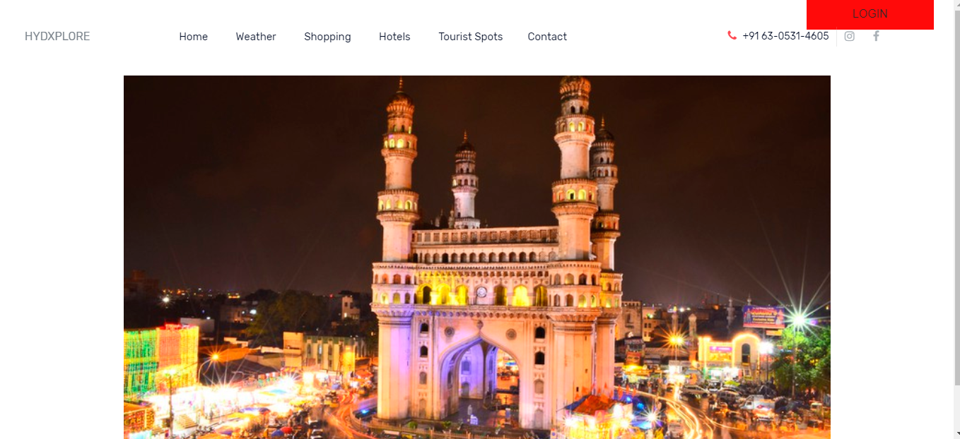

**Fig. 5.1 Main Page**

The main page of the website is displayed in the above Fig. 5.1. It contains slide show of pictures of famous places in Hyderabad.

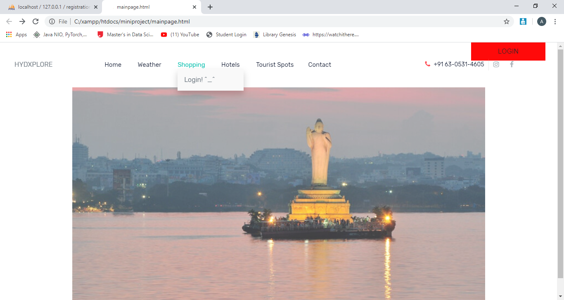

**Fig. 5.2 Main page before logging in**

Before logging in we cannot access Shopping, hotels and tourist places.

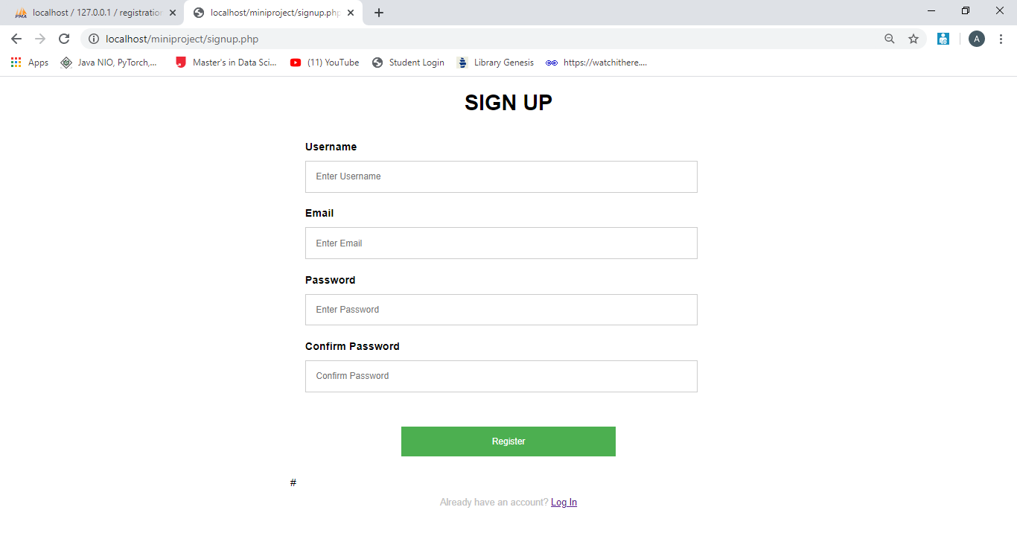

**Fig. 5.3 Signup form**

The login form of the website is shown in Fig. 5.2. This login form contains first name, last name and email-id columns, which are need to be filled by the users. If the details are not filled user cannot go to the next pages.

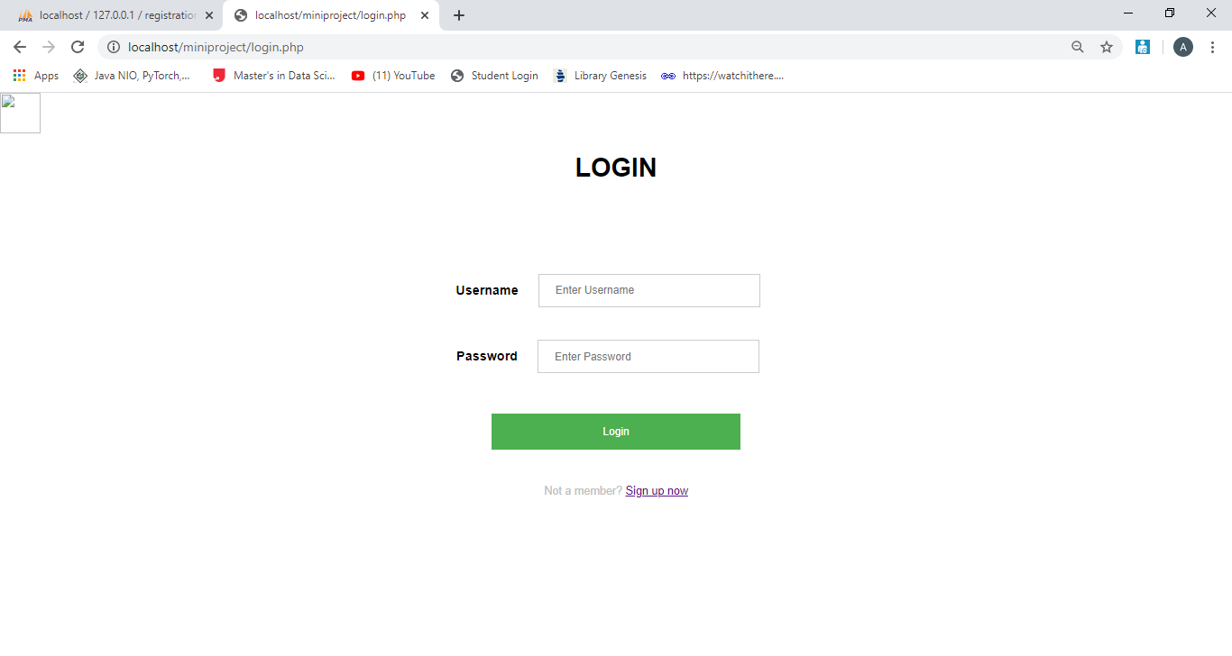

**Fig. 5.4 Login form**

In login form when the username and password is entered it checks them with the values stored in the data base while signing up. If there is a match then it redirects to the main page otherwise it displays incorrect password.

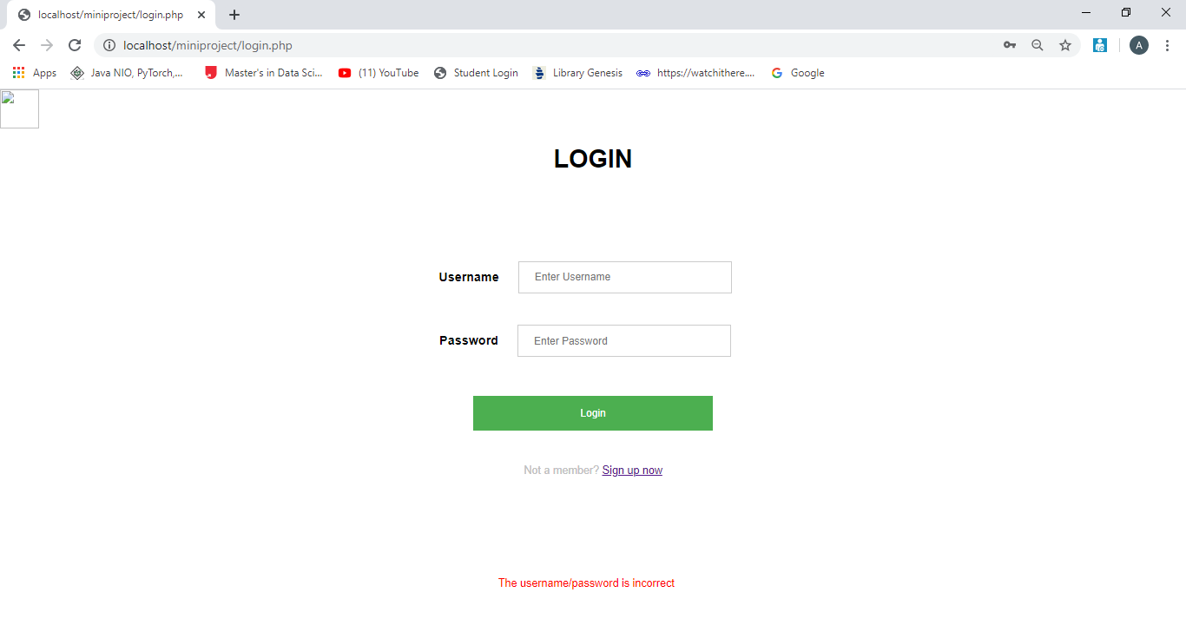

**Fig. 5.5 Login page when wrong details are given**

When you give wrong details while logging in you get a message

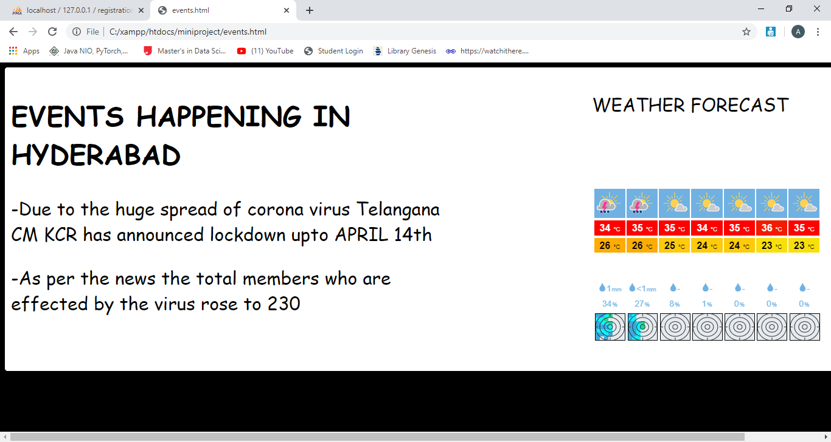

**Fig. 5.5 Weather forecast**

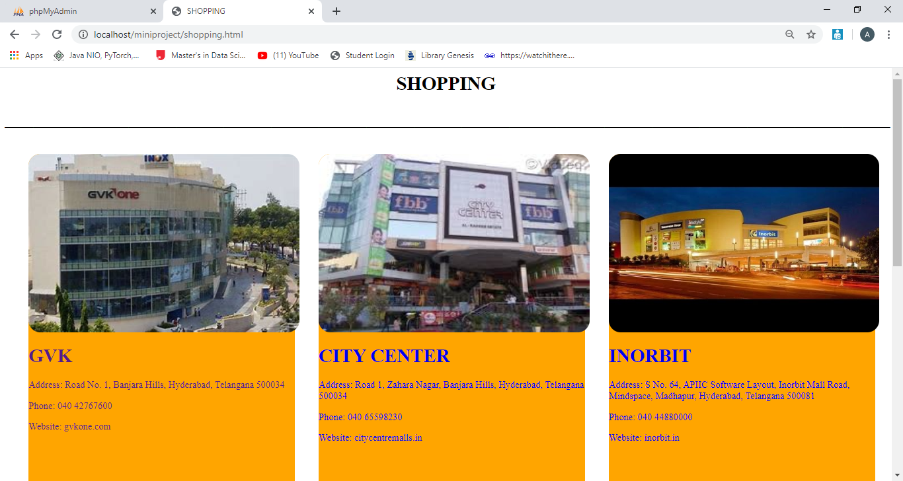

**Fig. 5.6 Shopping**

Some of the shopping places in Hyderabad are included in this page.

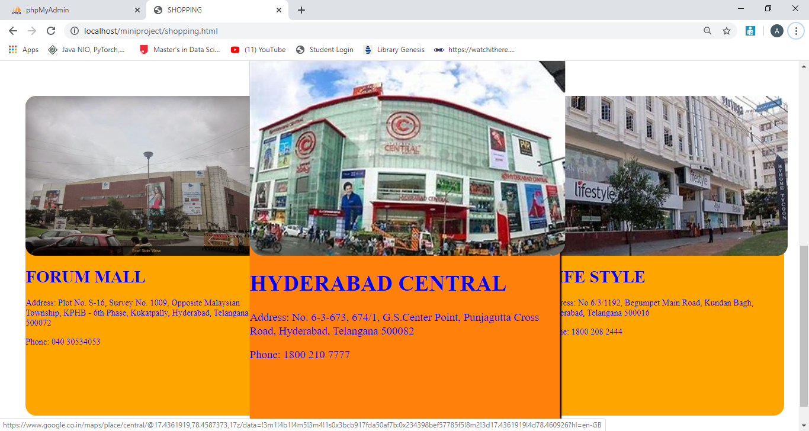

**Fig. 5.7 Shopping**

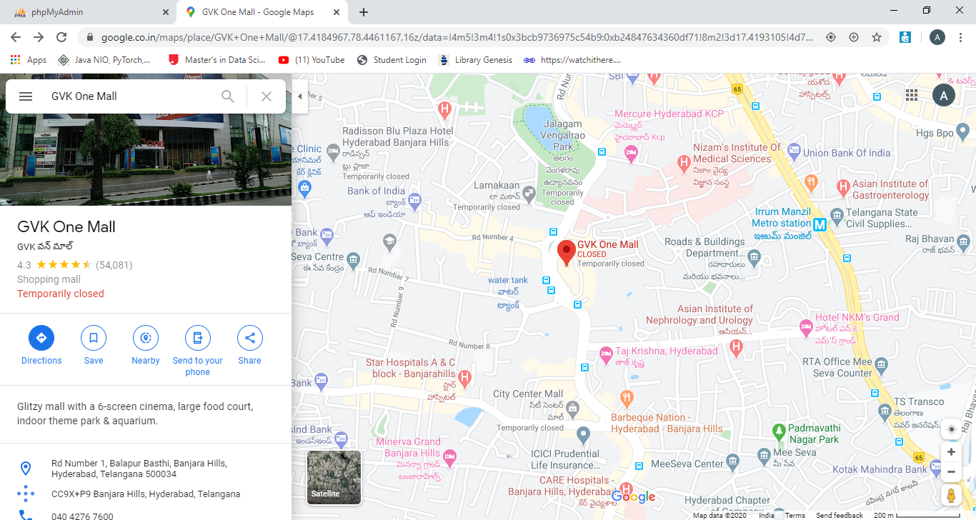

**Fig. 5.8 Directions page**

On clicking on any of the shopping mall it redirects us to the directions page where we need to set our current location and can see the directions to the particular shopping mall.

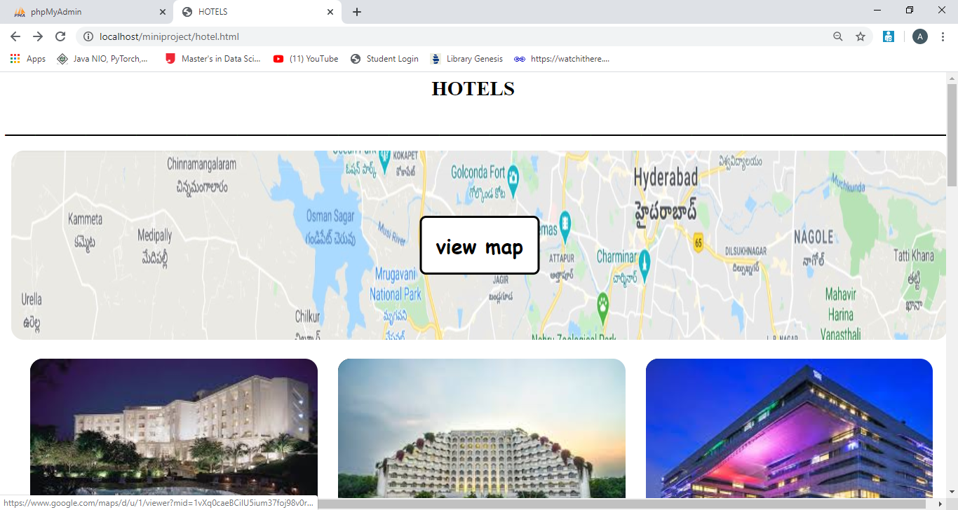

**Fig. 5.9 Hotels page**

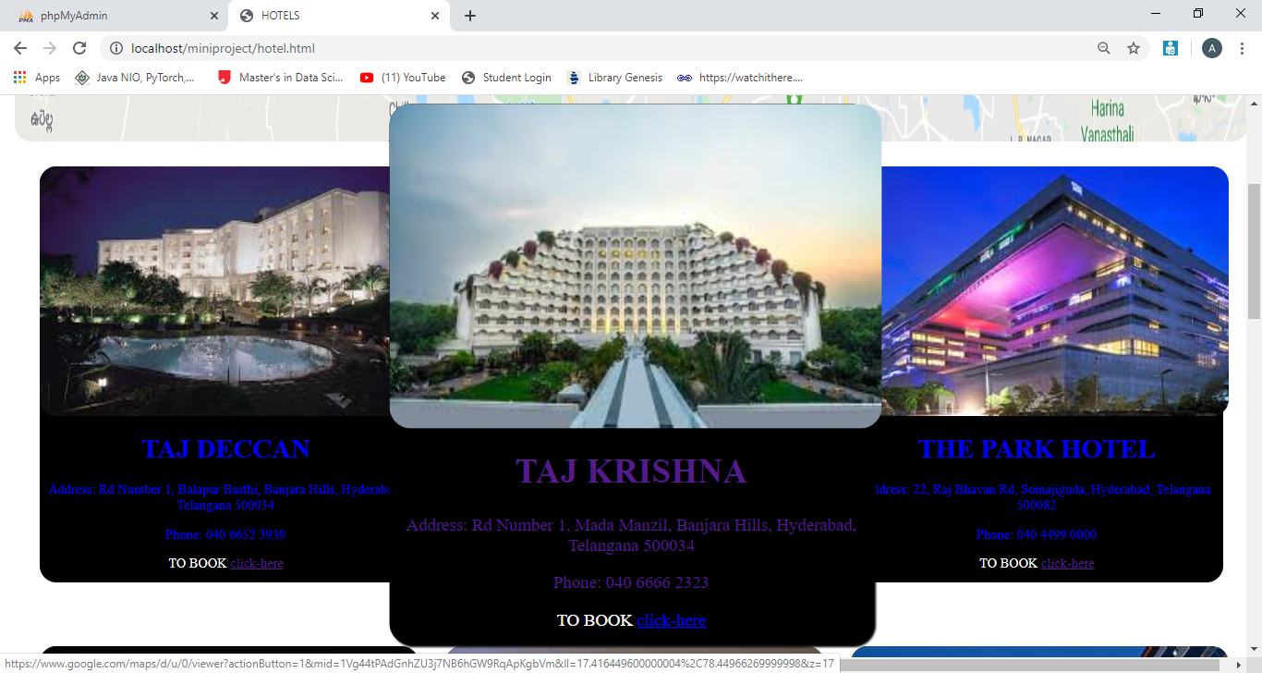

**Fig. 5.10 Hotels page**

Some of the best hotels of Hyderabad city are included in this webpage.

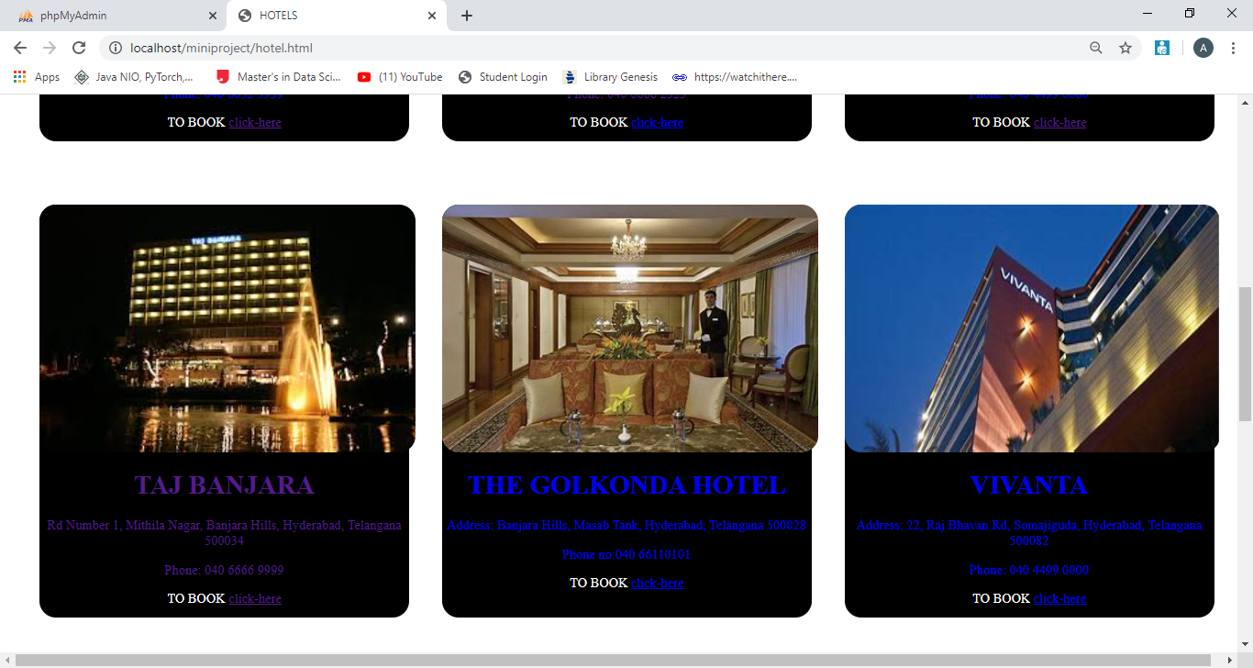

**Fig. 5.11 Hotels page**

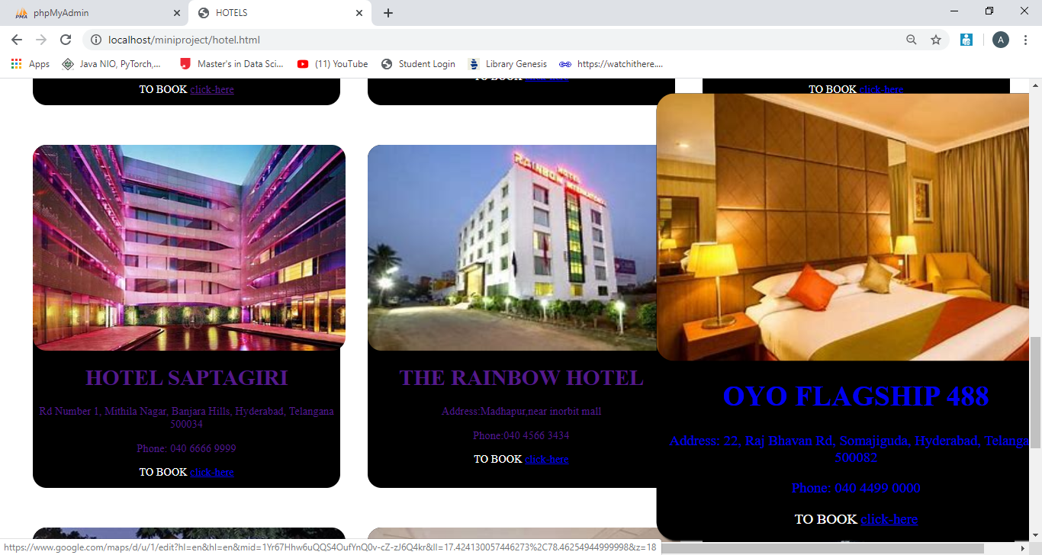

**Fig. 5.12 Hotels page**

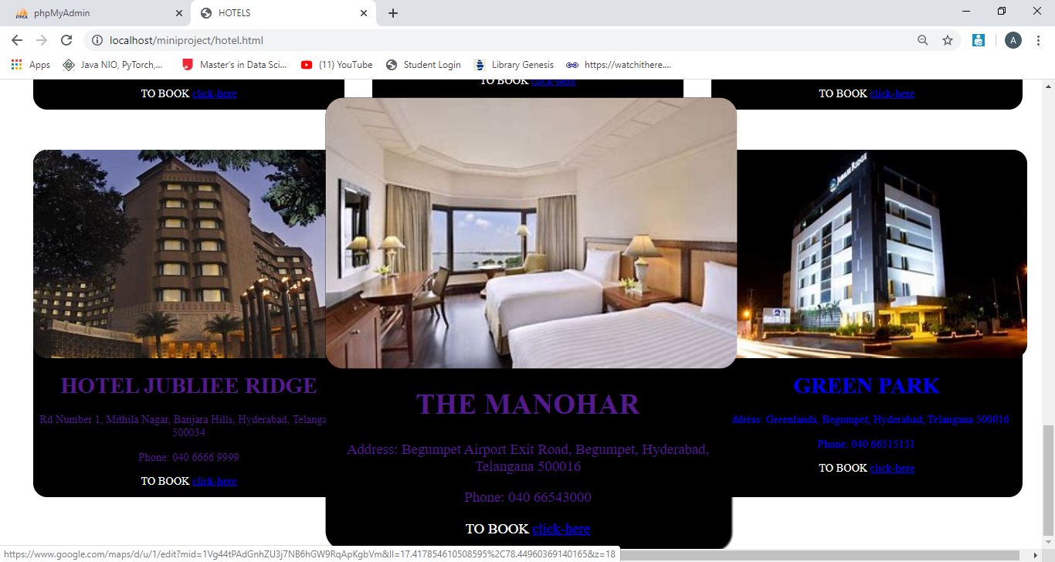

**Fig. 5.13 Hotels page**

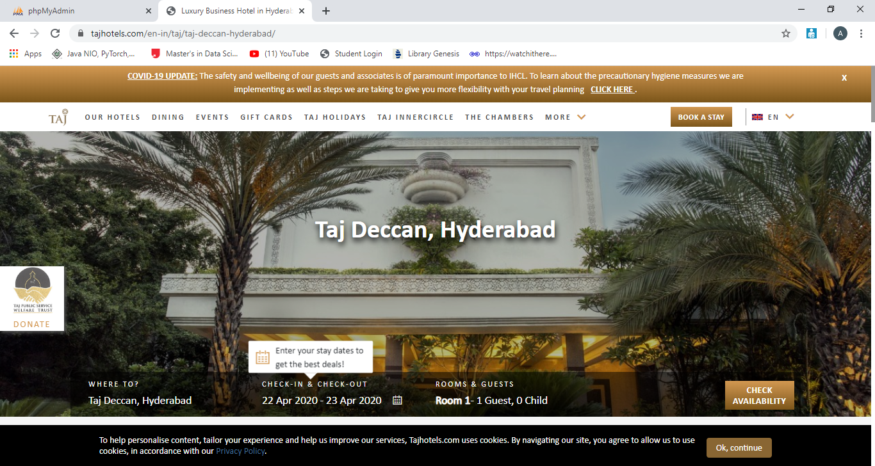

**Fig. 5.14 Book a hotel**

On clicking on book now it will redirect to the official website of that particular hotel and we can book tickets from that hotel website.

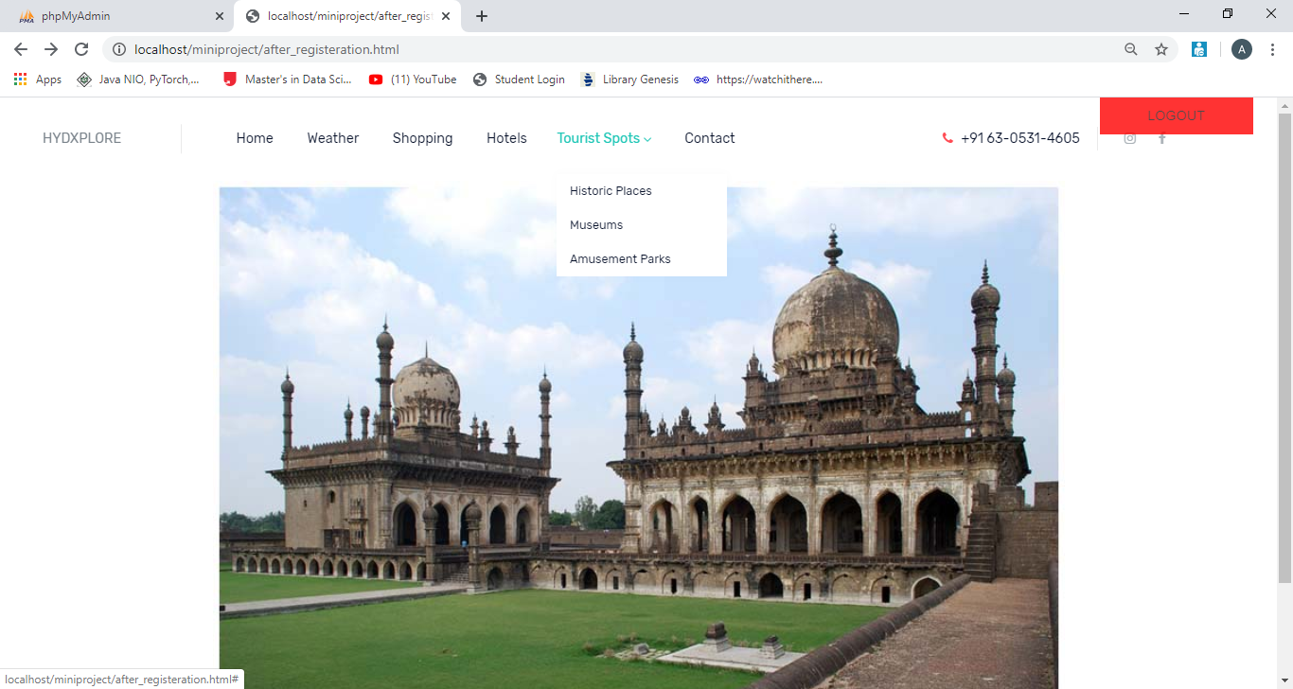

**Fig. 5.15 Tourist spots**

In tourist spots as we can see in drop down list, we have historic places, museums and amusement parks.

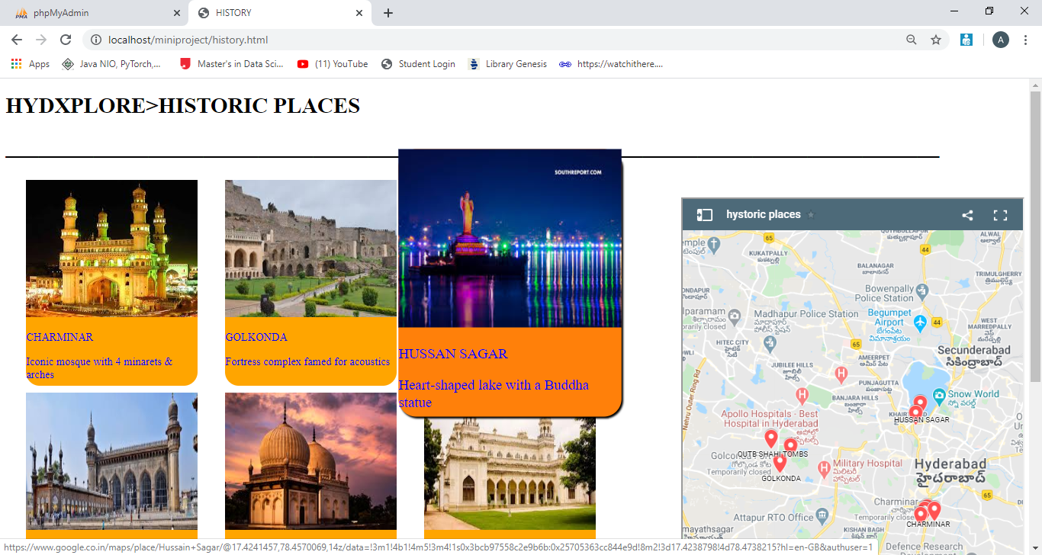

**Fig. 5.16 Historic places**

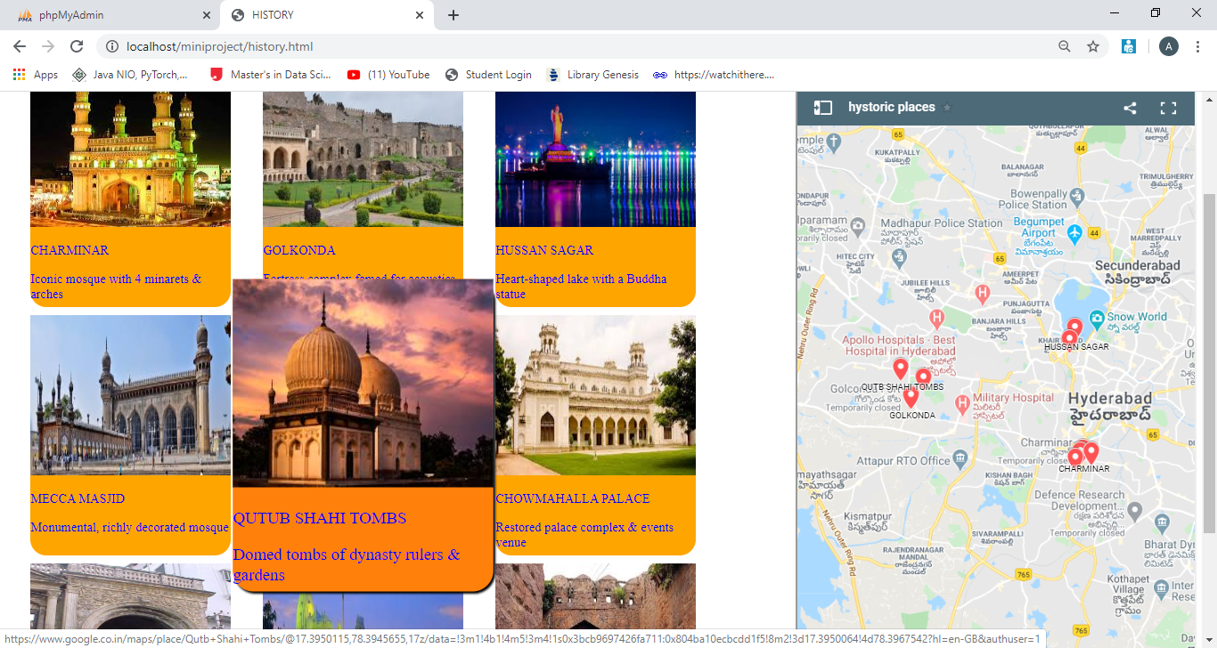

**Fig. 5.17 Historic places**

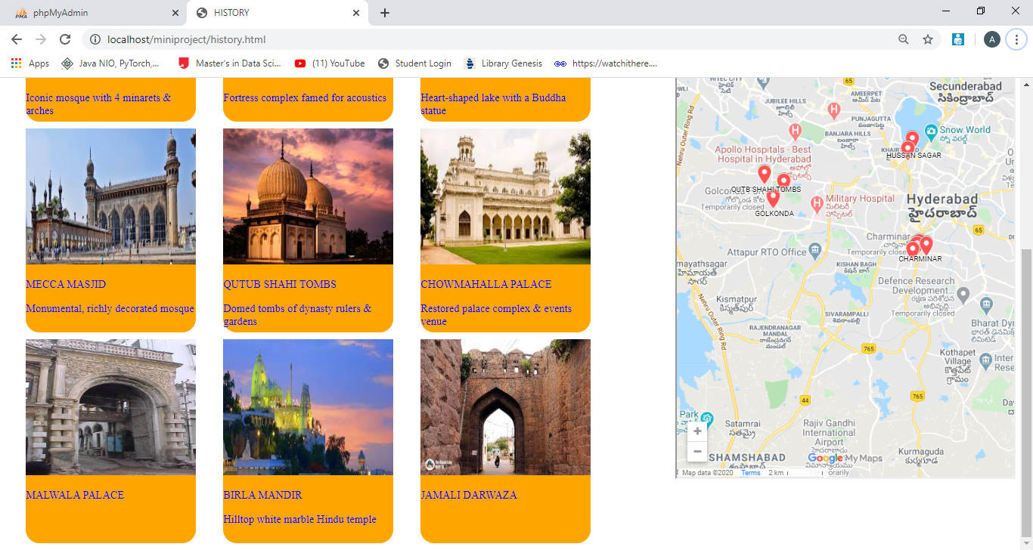

**Fig. 5.18 Historic places**

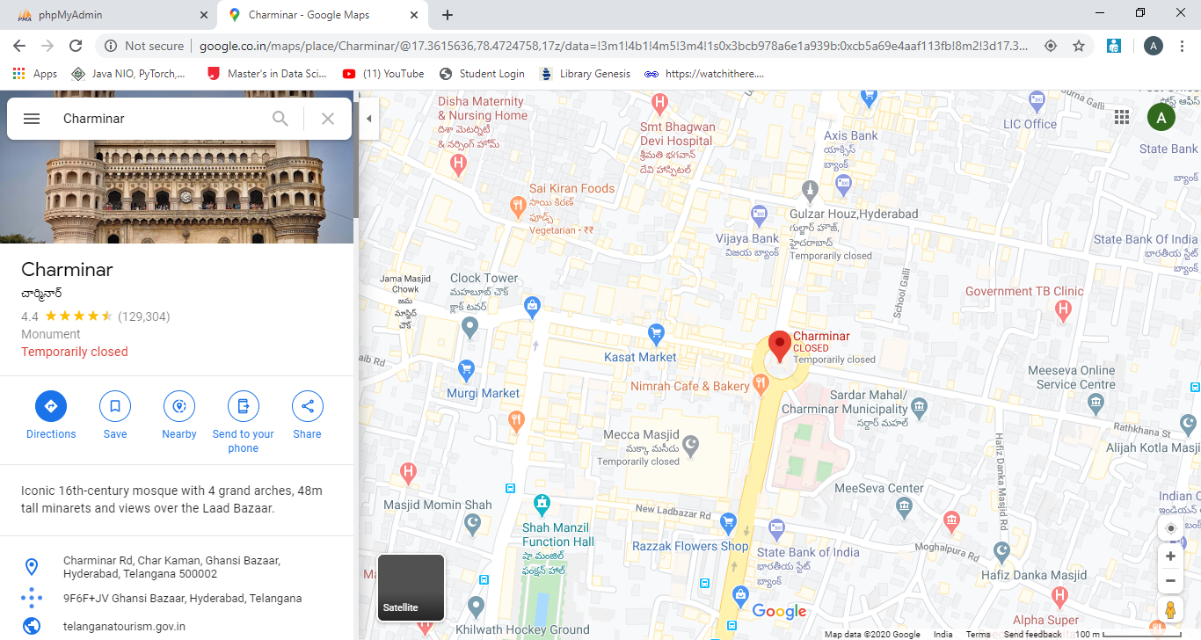

**Fig. 5.19 Directions page**

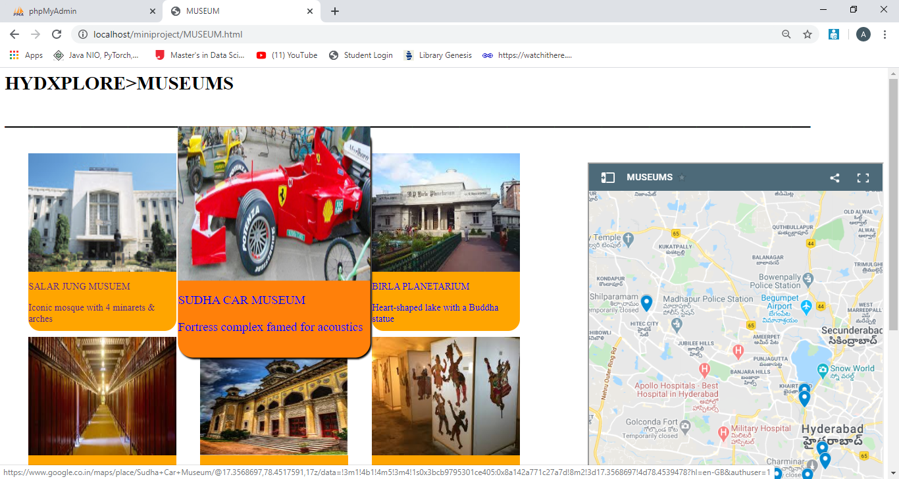

**Fig. 5.20 Museums**

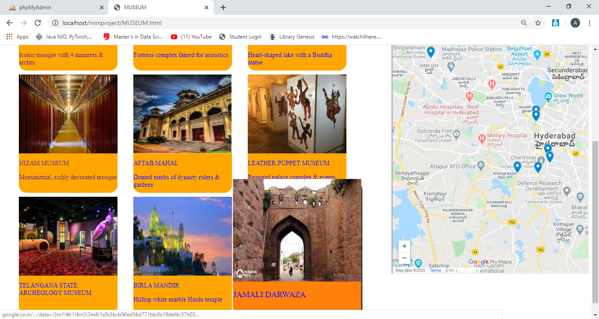

**Fig. 5.21 Museums**

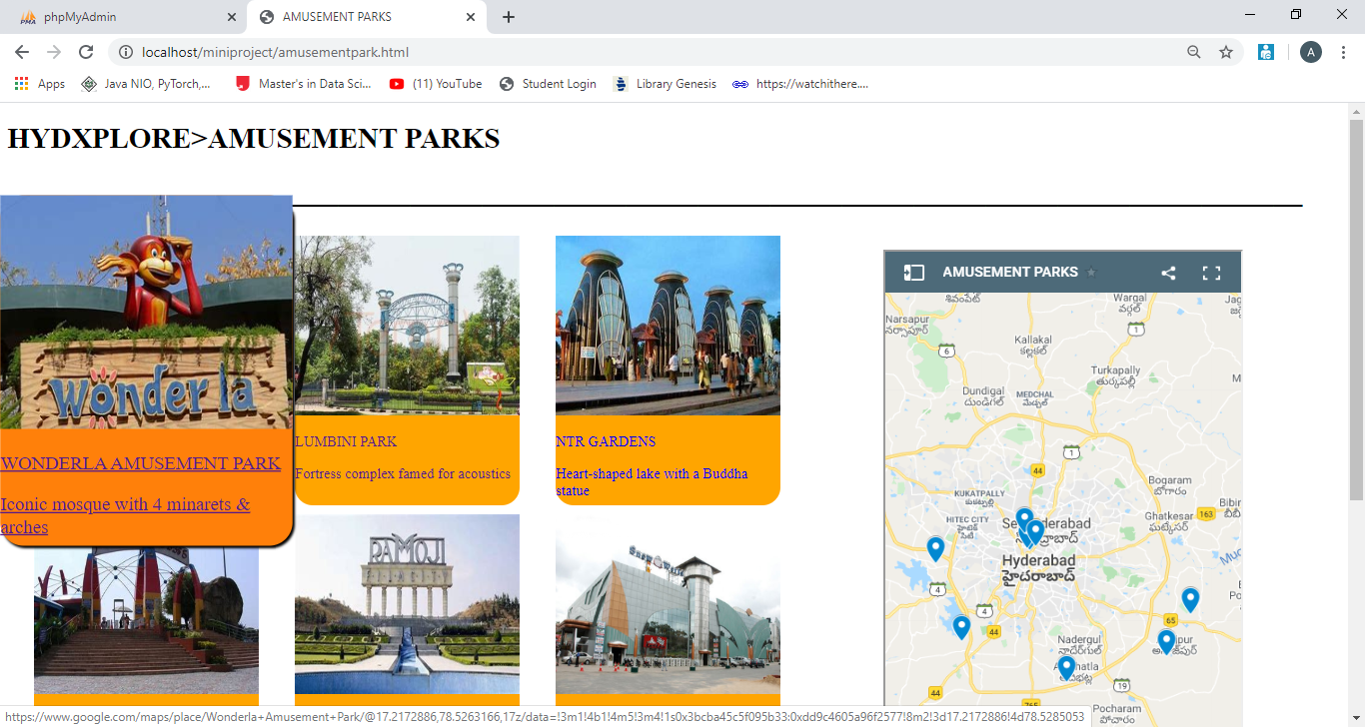

**Fig. 5.22 Amusement parks**

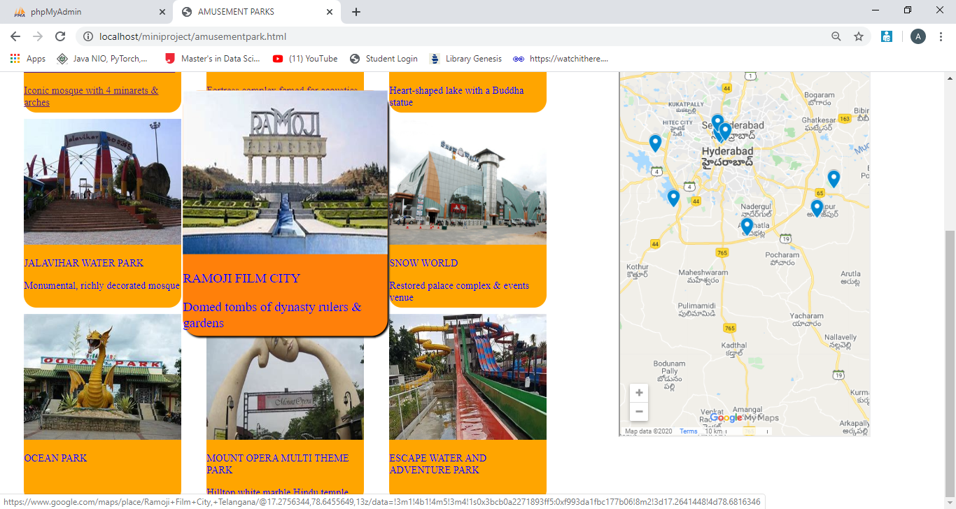

**Fig. 5.23 Amusement parks**

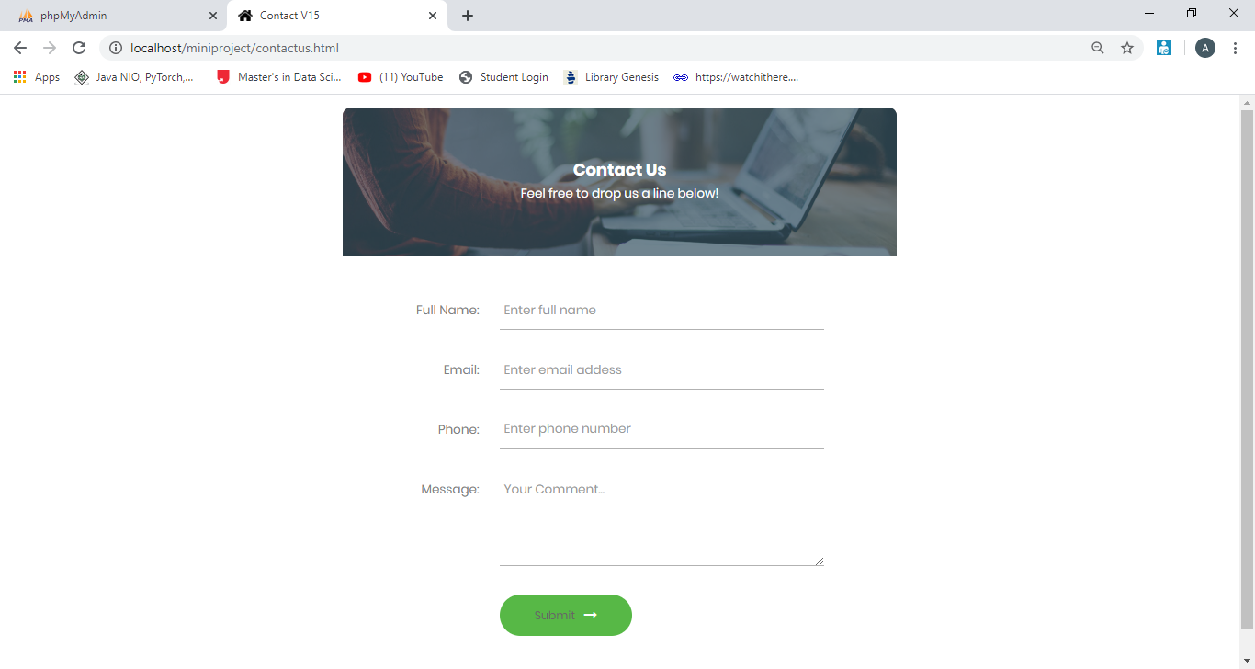

**Fig. 5.24 Contact us page**

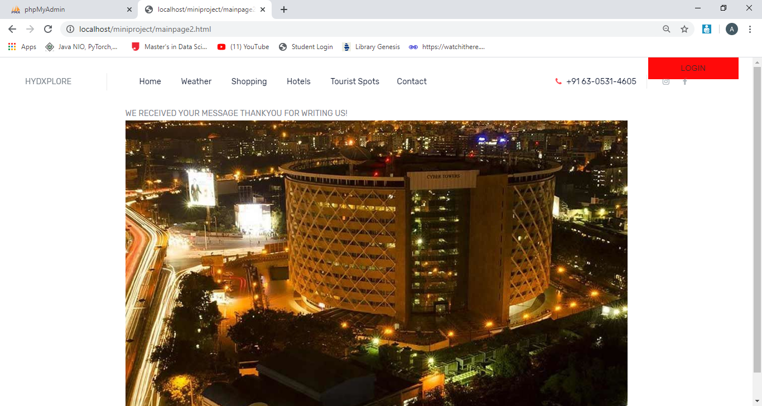

**Fig. 5.25 Main page**

On submitting the message in contact us page it will be redirected to this page.

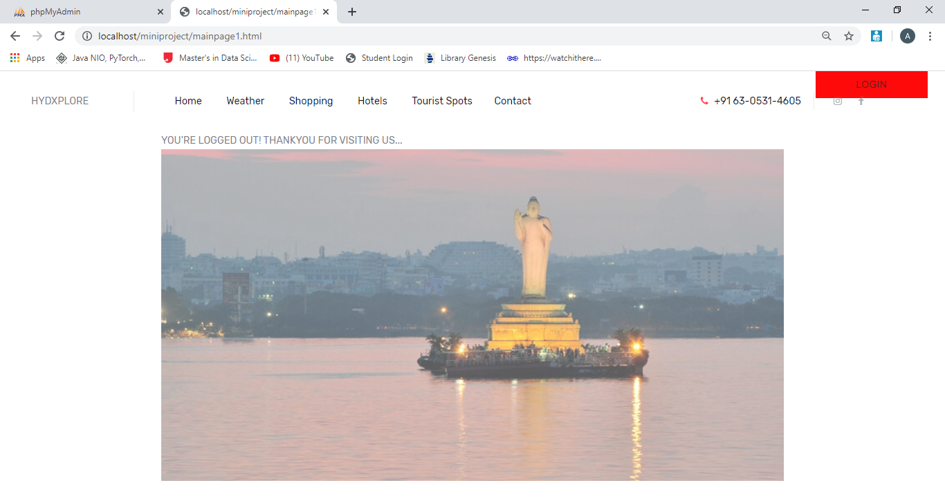

**Fig. 5.26 Logout page**

On clicking logout button it redirects to this page

**6 .CONCLUSION & FUTURE SCOPE**

The web application Hydxplore can be very helpful for every person who is new to Hyderabad. One can get all the details of the places located in Hyderabad in a single click. With this platform, the web application Hydxplore is developed, hoping to reduce time wastage, avoid misunderstandings, provide easy data flow, customer pleasure, and less hard work.

There is always scope for improvement and that is the case with our project as well. In the future few more features can be added to the website such as

✓ Making it more user friendly.

✓ We want to add more attractive styles to make the overall website appealing to the users.

✓ We want to host our website with a domain name in future.

**BIBLIOGRAPHY**

1. <https://www.w3schools.com/js/>
2. <https://www.tutorialspoint.com/javascript/index.htm>
3. <https://www.w3schools.com/html/>
4. <https://www.tutorialspoint.com/html/index.htm>
5. <https://www.w3schools.com/css/>
6. <https://www.tutorialspoint.com/css/index.htm>
7. <https://m.youtube.com/>
8. <https://www.quora.com/>
9. ​<https://www.youtube.com/watch?v=x_ZloJSP8c8>
10. <https://www.telanganatourism.gov.in/>